Saint James School

Rising 7th Grade Summer Assignments

**Required Literature:** Read *Wednesday Wars* by Gary Schmidt. Students should be able to summarize the book as well as have a grasp of the characters, plot, setting, and major events. There will be a test on the book during the first week of school.

**Suggested Math**: Math practice is strongly suggested for all students in order to keep skills sharp. Using MobyMax, practice math for 30 minutes per week using the *Math* and *Fact Fluency* tabs. Students who complete this math practice will be awarded extra credit toward their 1st quarter grade.

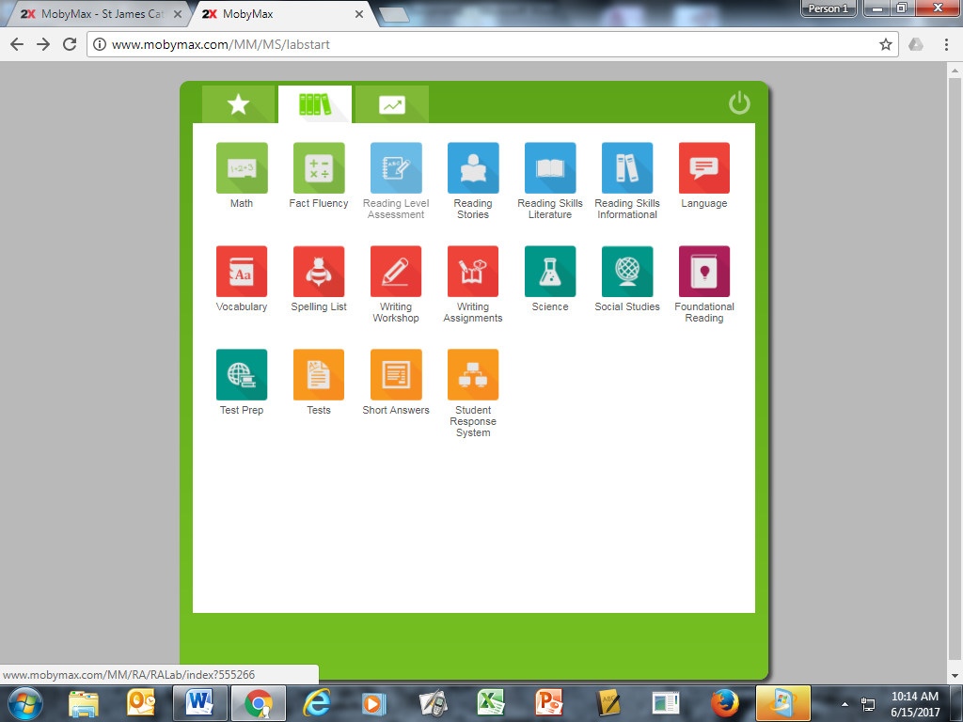

***Mobymax.com***

***School code: va2554***

***login: first initial + last name + sjs***

***password: rockets1***

Students who do not have internet access or who prefer to work on paper may purchase the workbook that is suggested for their math class and complete the practice for extra credit. Answer key is in the back of the book. Prices range from $12.

|  |  |  |
| --- | --- | --- |
| For 7th Grade Math class  *100+ Series Math Practice Grades 6+*  ISBN-10: 1568228600  ISBN-13: 978-1568228600  Do Even-Numbered problems. | For Pre-Algebra class  *100+ Series Mixed Skills in Math Grades 7-8*   * ISBN-10: 1568228619 * ISBN-13: 978-1568228617 * Even Numbers on pages:   1, 3, 4, 7, 8, 10-12, 14, 15, 21-23, 28, 32, 34, 37, 39, 42, 45, 46, 49, 50, 51, 54, 55, 63, 64,66, 72, 74, 76, 78, 80-82, 84-86, 88, 89, 91, 92, 96-98, 100, 102, 105, 106, 108-110,112 | For Algebra class  *100+ Series Pre-Algebra Grades 6+*  ISBN-13: 978-1-48381-013-3  Even Numbers on pages:  7, 9, 10, 12-15, 17, 18, 20, 22, 24, 27-29, 31-33, 35-38, 40, 41, 46, 47, 49, 50, 51, 52-55, 57, 58, 60, 61, 63, 65, 66, 67, 69, 70, 72, 73, 77, 78, 82-87, 94, 97, 98, 102 |

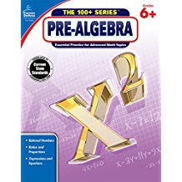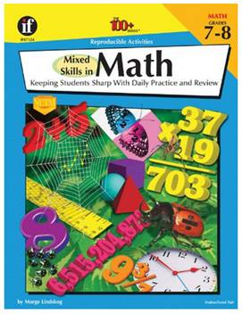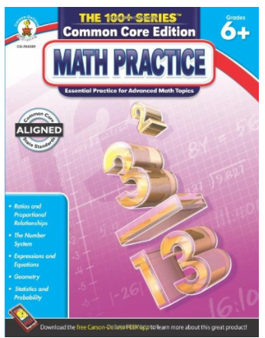

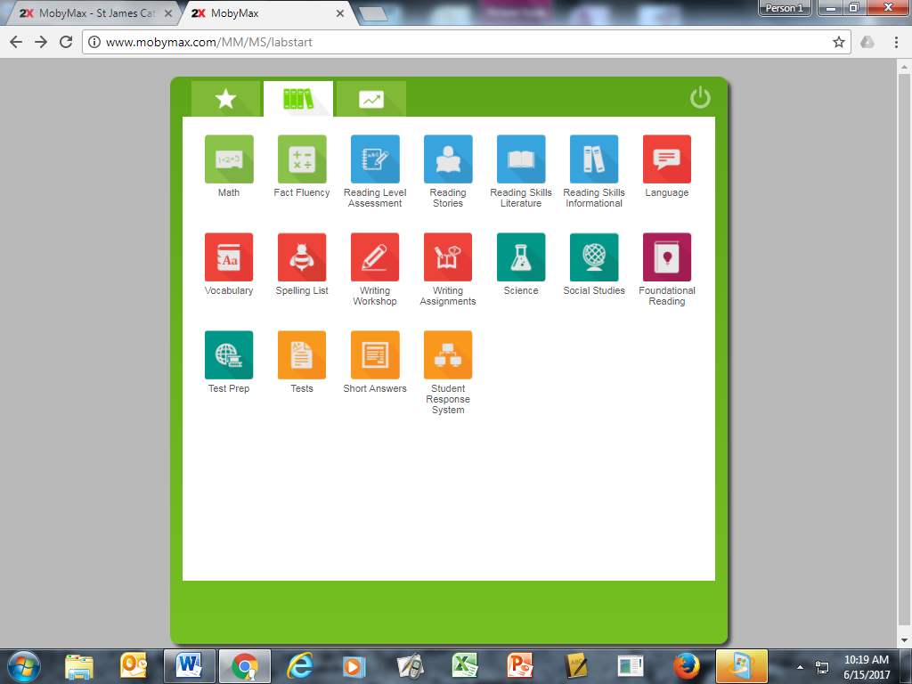

**Optional Grammar and Reading Practice:** All of the MobyMax topics are available to the students for optional practice including *Language* for practice grammar.