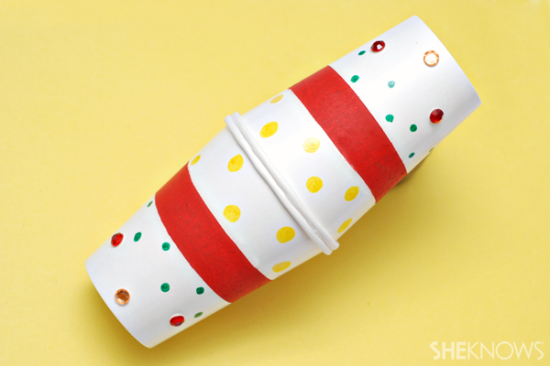

What you’ll need:
- Two large paper cups
- Paintbrush
- Red, white and green craft paint
- Dried pinto beans
- Hot glue gun
What you’ll do:
- Paint and decorate the outside of each paper cup.
- Let dry.
- Fill one cup halfway with dried pinto beans.
- Apply hot glue to the top edge of the cup.
- Place the second cup on the glue to create the maraca.
- Let dry.
https://www.sheknows.com/parenting/articles/957507/cinco-de-mayo-party-ideas/

