How to Type Accent Marks
On phone or iPad: hold down a & click on the option that looks like this: á
Accent Codes for Macs (for capital letters with accent marks, “Option e” then “Shift vowel”)

á | 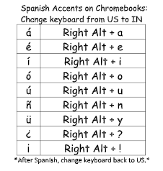  Option + e, a
é | Option + e, e
í | Option + e, i
ó | Option + e, o
ú | Option + e, u
ñ | Option + n, n
ü | Option + u, u
¿ | Shift + Option + ?
¡ | Option + 1

On a PC with number pad on right, hold down the “Alt” key while you type the numbers, and use the numbers on the right side of the keyboard.
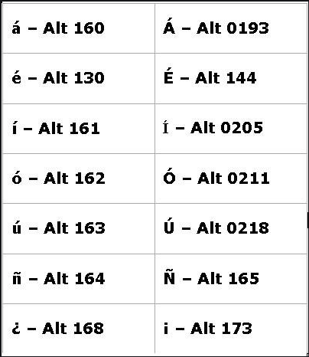
PC
Alt + 160 á
Alt + 130 é
Alt + 161 í
Alt + 162 ó
Alt + 163 ú
Alt + 164 ñ
Alt + 129 ü
Alt + 168 ¿
Alt + 173 ¡
Alt + 0193 Á
Alt + 144 É
Alt + 0205 Í
Alt + 0211 Ó
Alt + 0218 Ú
Alt + 154Ü
Alt + 165 Ñ

On PC with number pad on right:

On Mac:
